## **Dr.N.G.P. INSTITUE OF TECHNOLOGY**

**(An Autonomous Institution)**

**Approved by AICTE, New Delhi & Affiliated to Anna University, Chennai**

**Recognized by UGC & Accredited by NAAC with A+ & NBA**

**[BME, CSE, ECE, EEE and Mech]**

**DEPARTMENT OF ARTIFICIAL INTELLIGENCE AND DATA SCIENCE**

**MINI PROJECT**

# **On Food Ordering System**

**Submitted by**

**KABILAN N 710721243021**

**KRISHNA KUMAR S 710721243027**

***in partial fulfilment of the requirements for the award of***

***the degree of***

**BACHELOR OF TECHNOLOGY**

**in**

**ARTIFICAL INTELLIGENCE AND DATA SCIENCE**

**Dr.N.G.P. INSTITUTE OF TECHNOLOGY**

**DEPARTMENT OF ARTIFICAL INTELLIGENCE AND DATA**  **SCIENCE**

**JANUARY 2024**

|  |  |  |
| --- | --- | --- |
| **S.NO** | **TABLE OF CONTENTS** | **PG.NO** |
| 1. | ABSTRACT | 02 |
| 2. | INTRODUCTION | 03 |
| 3. | KEY FEATURES | 04 |
| 4. | TECHNOLOGY USED & TECHNICAL STACK | 06 |
| 5. | UML DIAGRAM | 07 |
| 6. | WEBSITE OVERVIEW | 08 |
| 7. | CONCLUISION | 09 |

**ABSTRACT**

The Food Ordering Website is a web-based platform designed to streamline online ordering for restaurants. This system leverages HTML for the user interface and Java to store and manage order data in a backend database. Key features include user registration and login, a menu displaying food items available for order, an intuitive ordering process allowing customers to select items and quantities, and order tracking on the restaurant side. By automating the ordering process and integrating with restaurant systems.

**INTRODUCTION**

In a fast-paced world, convenience is key – even when it comes to something as everyday as ordering food. The Food Ordering Website provides a streamlined platform for hungry customers to order meals from their favorite local restaurants and have them delivered straight to their door.

This online system allows customers to browse menus and place orders from various regional restaurants all in one place. With real-time information on restaurant availability, food prep times and delivery fees, customers can efficiently plan their food ordering experience without the hassle of calling multiple places. The Food Ordering Website makes finding, ordering and tracking delivery food quick, simple and stress-free.

Key features include user-friendly menu browsing, integrated payment processing, live order tracking and customizable delivery instructions. Customers can manage all their food orders and delivery preferences from the convenience of a single account. With many households relying more on food delivery while leading busy lives, the Food Ordering Website seeks to make mealtimes easier. This system offers the ideal intersection of convenience, variety and ease for today's on-the-go foodies.

**KEY FEATURES**

**User Registration and Authentication**: Users can create accounts and log in securely to access the system's features.

**Food Items Listings**: The system displays our signature dishes.

**Quantity Selection:** The system allows users to order as much as food required for them

**` TECHNOLOGY USED**

• Frontend: HTML.

• Backend: Java Servlets for handling user requests and database interactions.

• Database: Relational database MySQL to store transport and route data.

• Development Tools: Java IDE Eclipse.

**TECHNOLOGY STACK**

1. Java:

- Leveraging the power of Java for backend development, ensuring robustness, scalability, and compatibility across different platforms.

2. HTML:

- Employing HTML for creating a dynamic and responsive user interface, providing an engaging experience for users accessing the system from various devices.

3.Servlet:

- Utilizing servlet technology to handle requests and responses, enabling seamless communication between the frontend and backend components of the system.

**UML DIAGRAM**

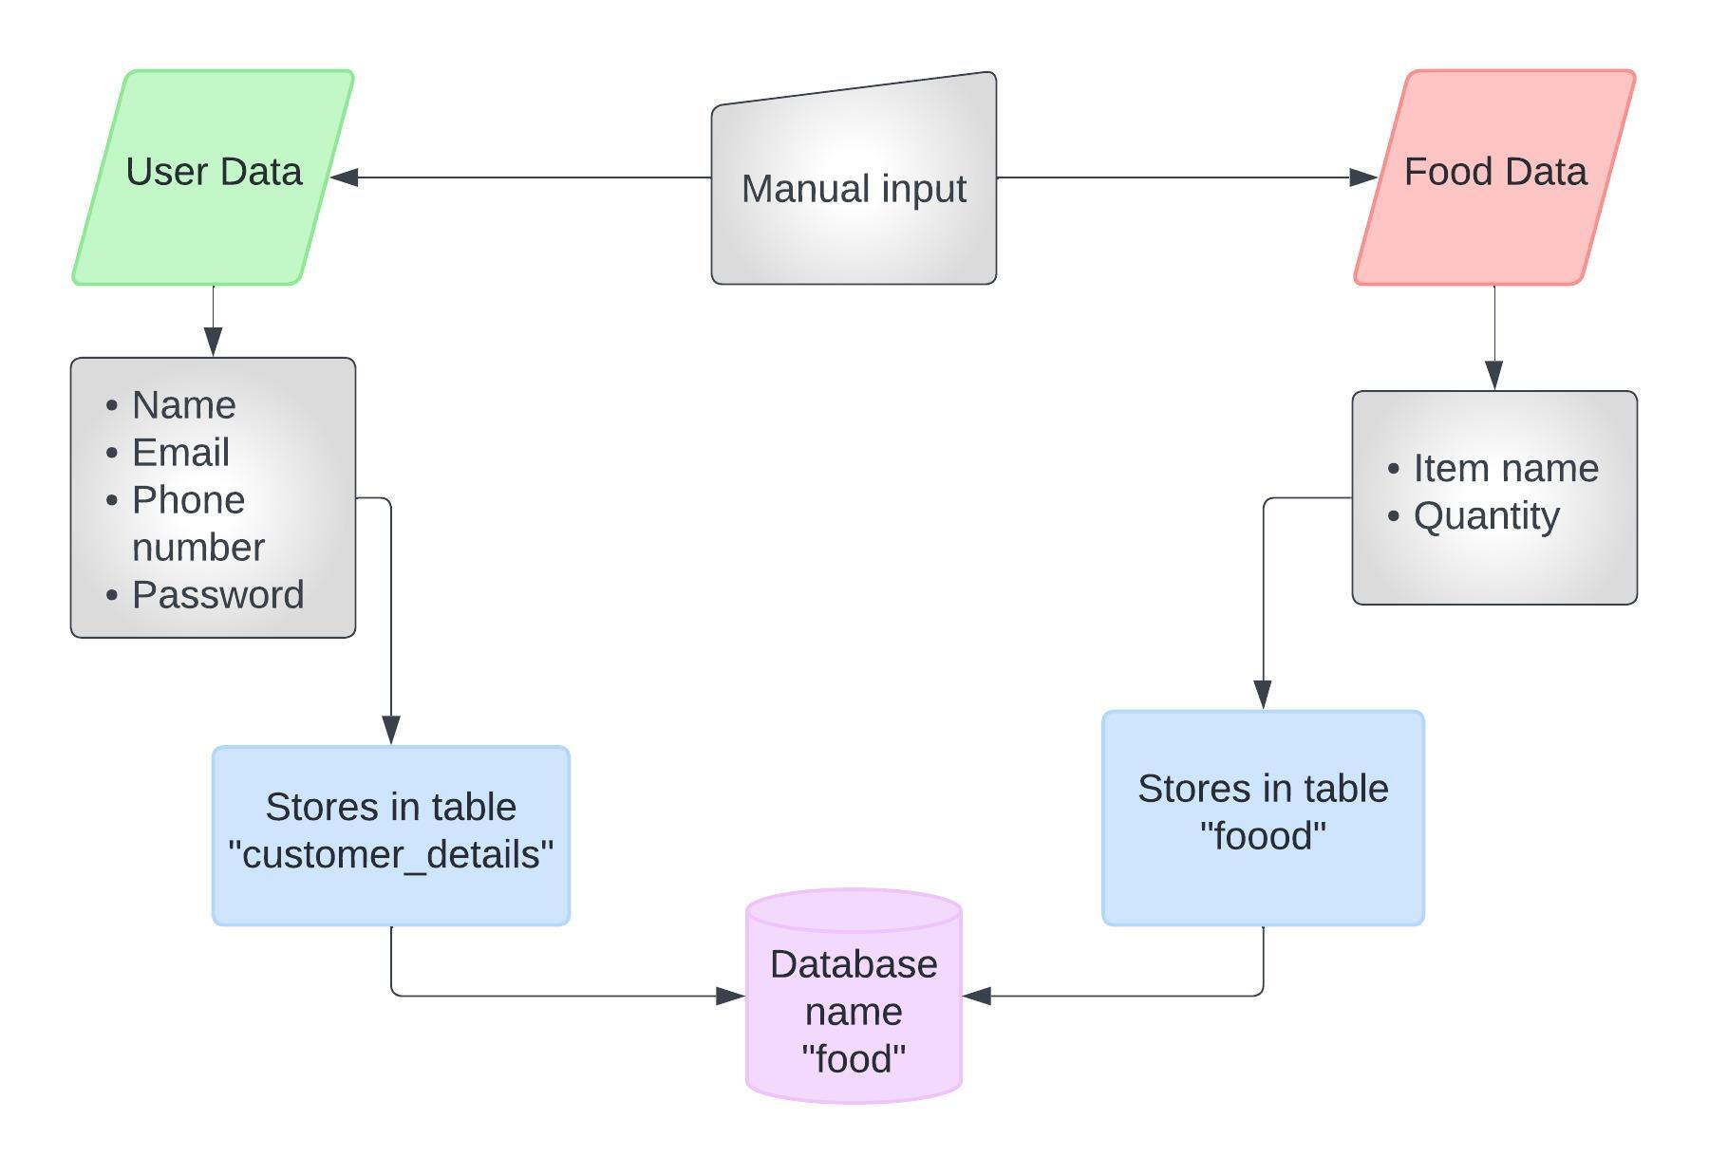

**WEBSITE OVERVIEW**

***LOGIN PAGE:* 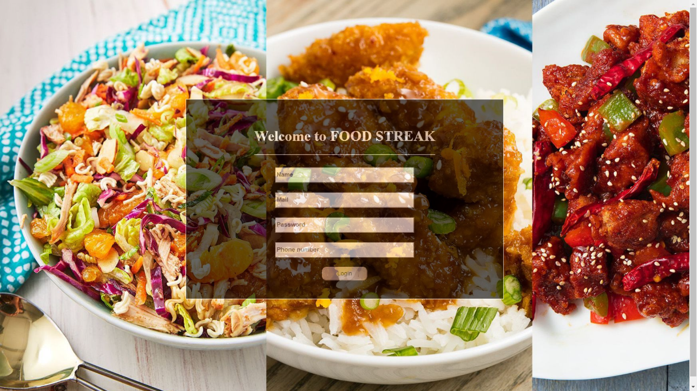**

***THEATRE AND MOVIE SELECTION:***

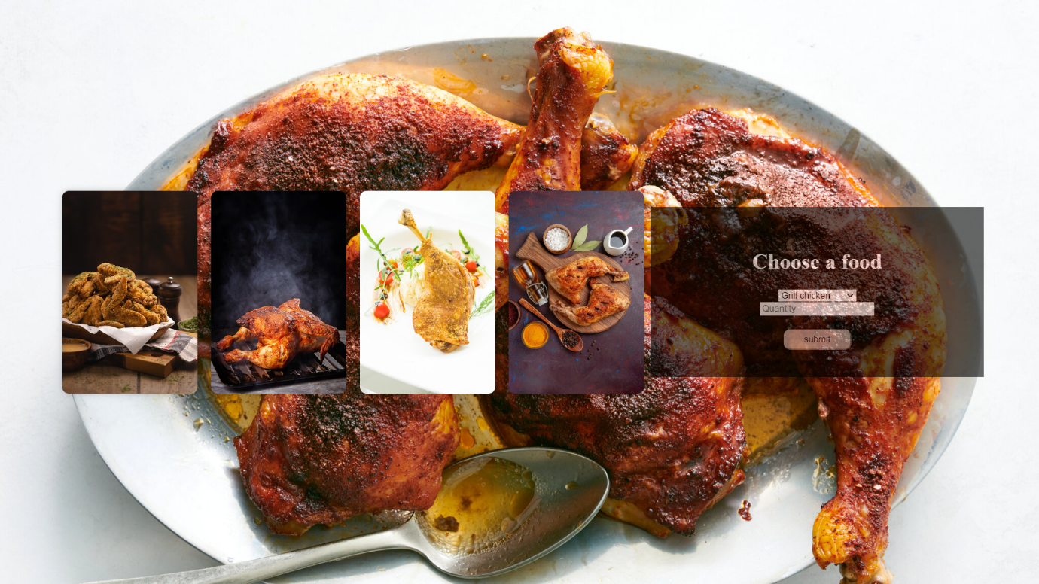

***THANKYOU PAGE:***

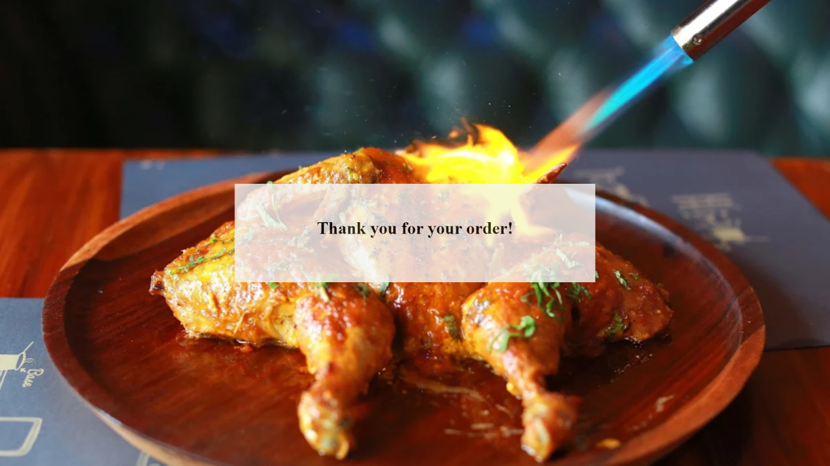

**CONCLUSION**

In conclusion, the Food Ordering Website presents a pioneering solution to the ever-growing demand for convenient and efficient food delivery services. By integrating advanced technology with user-friendly design, this platform offers customers a seamless experience from browsing menus to doorstep delivery. Through its robust features and intuitive interface, the website not only enhances accessibility for users but also streamlines operations for restaurants, fostering growth in the food service industry. As we navigate an increasingly digital landscape, this project underscores the importance of innovation in meeting the evolving needs of consumers while setting new standards for online food ordering platforms.